Green Play Ammonia Scouting Trip #1 January 11 – January 16, 2022

As the Senior Project Engineer for Green Play Ammonia, I’ve been excited to make it out to the Midwest to meet with farmers and see the lay of the land. In my view, it’s crucial to immerse myself as much as possible in the land, culture, and people so that I can understand the needs and challenges that lie ahead for our business venture.
In early January, I started my first week-long trip to the Midwest by flying into the Amarillo, Texas airport where Green Play Ammonia’s founder, Guy Swanson, picked me up. We headed straight for Pampa, Texas where we spent the next four days. Around Pampa, I was introduced to some of the farmers who run large-scale farming and manufacturing operations, including SCARAB International, a company that produces industrial compost machines for domestic and international sales. One of our first sites will likely be located outside of Pampa, not far from SCARAB. We have a farmer friend who is interested in our business plan and has available land for our first system. The land has high quality wind, solar, and good road access.

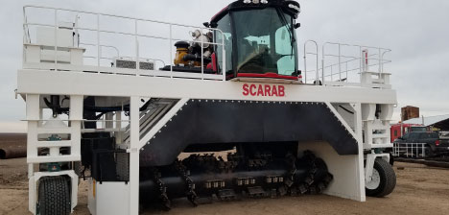
SCARAB Machines, Texas

The area around Pampa, and north Texas in general, is peppered with large wind turbines that take advantage of the steady strong winds coming from north to south. The solar resources in the Texas Panhandle are also very good quality – ideal for combining with wind to produce reliable renewable energy for green ammonia production. Energy analysis is underway to determine the right combination of the two to maximize energy production over the course of a year and minimize the cost. In general, solar energy production is at its best in the summer – naturally - because the sun is out for longer periods of time. On the contrary, wind is often better during the winter and spring, and lower during the summer peak. Hence, when we combine the two technologies, they complement one another. What will Green Play Ammonia do when it’s nighttime in the summer? If there’s no wind, and the sun is down, how will we provide energy into our electroyzers to produce hydrogen? How will we keep our Haber-Bosch plants running? Do not fret, friends, we have a solution to this! During times when we need extra power input because of no solar resource and little wind, we can take advantage of local plant oil and biofuels which we can combust in a diesel generator. Yes, there are large MW size generators available that can burn all kinds of fuels. And for those that are concerned about the combustion byproducts, I assure you that any fuel we use will not come from fossil fuels, so they will be carbon neutral! We have other potential options to supplement our energy needs, and these will depend on our location, but could include pumped storage, compressed air, or perhaps even using our own ammonia product for heat and power if the economics make more sense than turning off our ammonia plant completely. The goal, of course, is to keep our plant running as much as possible throughout the year, because the more production the better the economics, and the happier we make our customers. They will be, after all, relying on a steady supply from us.

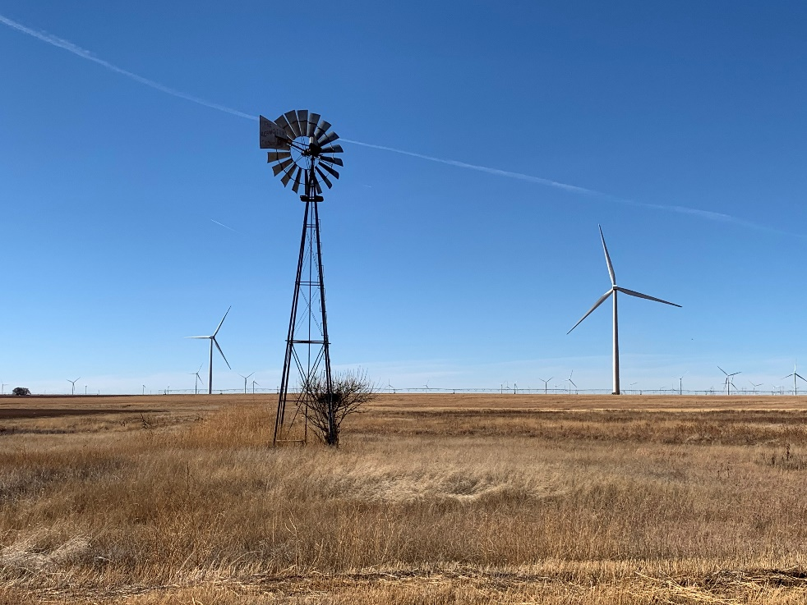
North Texas

Following Pampa, we made our way north through the Oklahoma panhandle to Hugoton, Kansas where we met more potential business partners for a nice dinner. Along the way, while driving, my eyes were drawn to sporadic oil pump jacks slowly nodding up and down across the flattened landscape. If I stared long enough at one, I may have just about been hypnotized to sleep if wasn’t for the 50-mph constant wind throwing corn husks at our moving car. At least the ground wasn’t too dry, or surely, we would have been in a full-on dust storm. Eventually, we made it to the Abengoa bioenergy plant near Hugoton. Originally funded through the DOE, Abengoa is a versatile plant that can utilize many different types of bio-waste for energy recovery and biofuel synthesis.

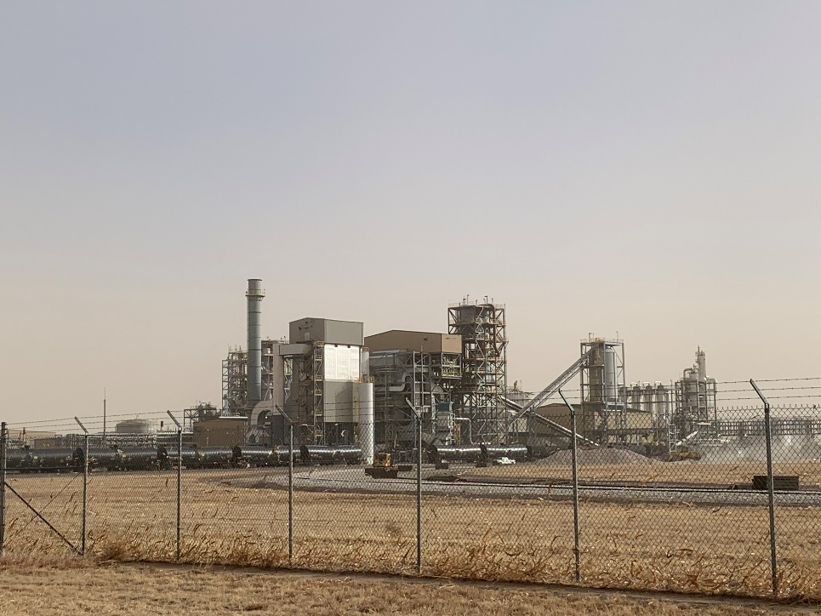
Abengoa Bioenergy Plant, Kansas
After Hugoton we made our way north toward Colorado by way of western Kansas. Outside Denver, the wind farms are abundant and plentiful – and most of them are spinning with gusto. This was a good sign for me, as typically during my trip to Portland, Oregon the wind turbines in the Columbia gorge are often stagnant. This is, of course, is due to the lower average wind speed which diminishes the yearly average output.
Finally in Denver, we made it to the natural history museum for 45 minutes before closing. Thankfully, Guy enjoys dinosaur bones, minerals, and outer space exhibits as much as me so our short time in the museum was quite enjoyable.

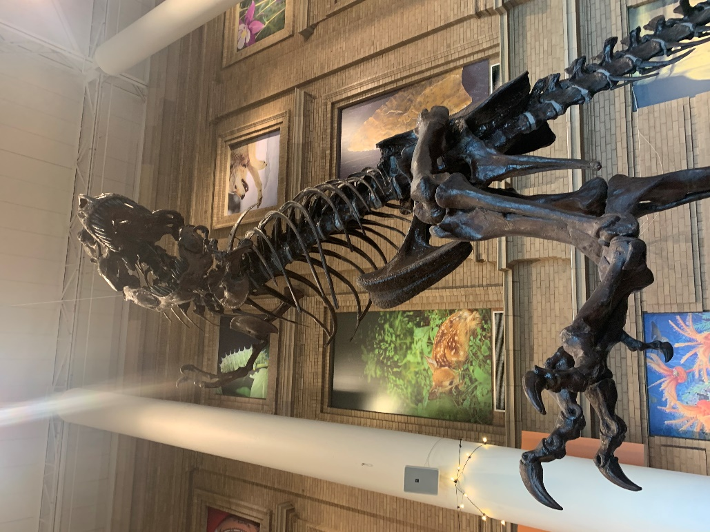
Denver, Colorado Natural History Museum

- Nathan Crary
Senior Project Engineer
Green Play Ammonia

Green Play Ammonia Scouting Trip #2 January 30 – February 5, 2022

Two weeks later, I was back on the road with Guy Swanson. This time we both started in Denver and headed east to visit a proposed site for one of our first ammonia plants. The site is pretty much ideal for an anchor plant: good wind, flat ground, water access, cheap land, and good enough solar to provide ample power for ammonia production. A potential business partner owns a farm next to the land and he could end up being a key player in the development of this site. After a good visit with him, Guy and I headed to Burlington for the night. The next day we made it to the John Deere store where I bought a hat and a toy for my daughter. Following reports of a storm coming through Denver in route to Kansas, we turned around from there and headed back to Denver with the possibility, in our mind, of flying back to Spokane early to avoid the storm moving in.
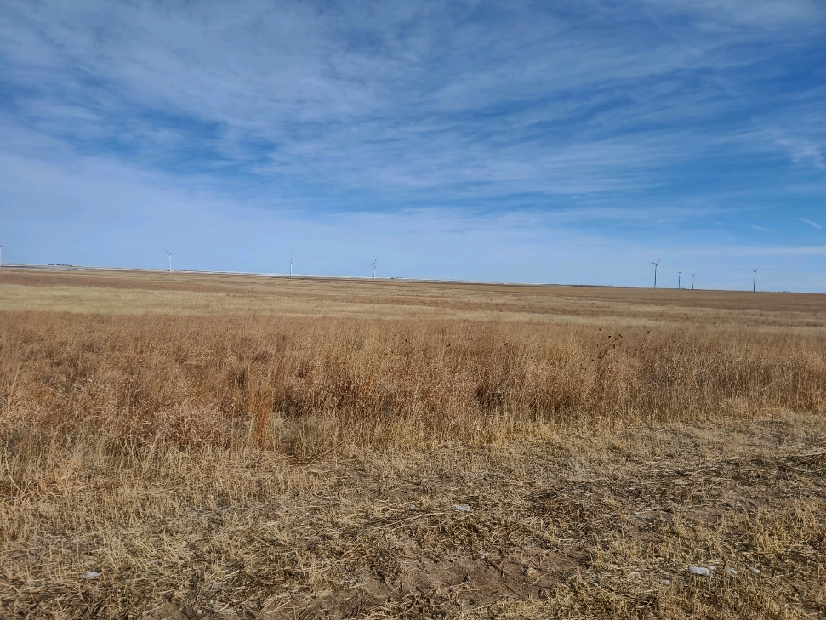
Colorado, Possible Site for Ammonia Plant
Fortunately, the next day we learned the storm coming in by nightfall would be moving more south into southern Kansas and Oklahoma. With this weather-window, we made the decision to get back on the road, albeit this time more north, through Nebraska. By the way, I’ve never seen Nebraska, so I couldn’t let a little winter storm keep me from seeing the epicenter of North American industrial-scale agriculture. Along the way toward our destination of Grand Island Nebraska, we stopped for an hour in Gothenburg, Nebraska where I finally got to achieve my dream of joining the historic Pony Express! Guy informed me that we still had other work to do, so when we finally get to a good point of project completion, I’ll return to Gothenburg with a pony to ride, a leather mail pouch, and a twinkle in my eye

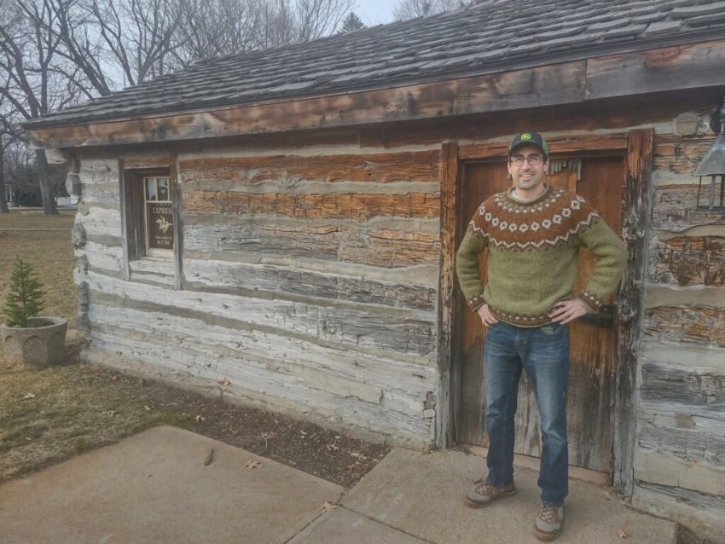
Pony Express! Gothenburg, Nebraska

With Grand Island as our base for a few days, Guy and I met with some of his long-time customers – customers who own and operate large farms, both seed and crop. We had some great introductions and conversations on the state of Nebraska agriculture and how our Green Play Ammonia systems will benefit the farming industry for generations to come. We also had the chance to attend an agriculture seminar outside of Grand Island where we met John Hay, a very knowledgeable agriculture educator, face-to-face. Again, we had another great conversation on the state of Nebraska agriculture and how our systems can benefit it. So far, so good!

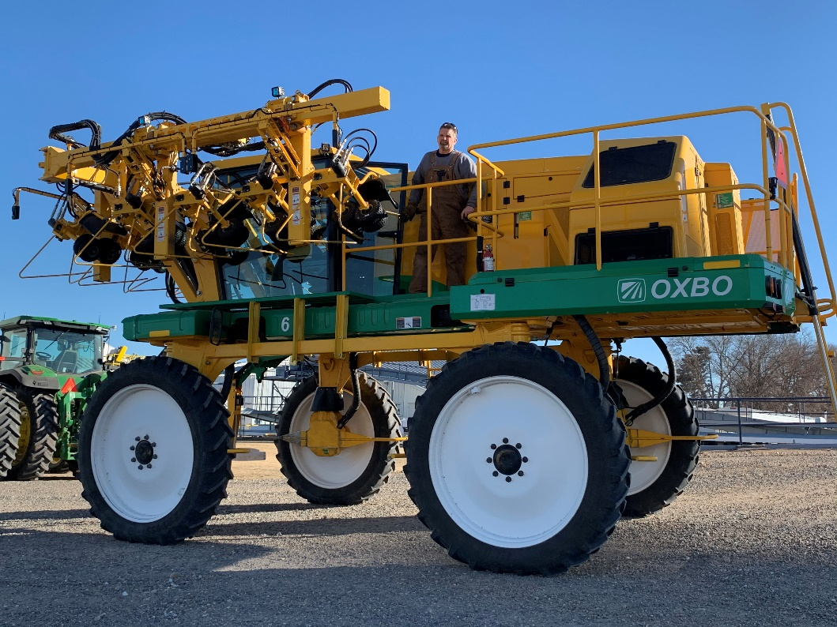
Meeting with Potential Partners, Nebraska
Outside of Grand Island, we stopped by Bosselman, a company that manufactures and sells ammonia tanks. There are a handful of companies that produce these and Bosselman may well be one we choose to partner with. A statue outside the Bosselman office shows two brothers, last name Martin, (aged 12 and 15) escaping by horse while being pursued by either Sioux or Cheyenne Indians. They had been shot with arrows multiple times, but managed to escape and survive, although not without lingering injuries. The history of the Great Plains is rife with wild stories of all kinds. 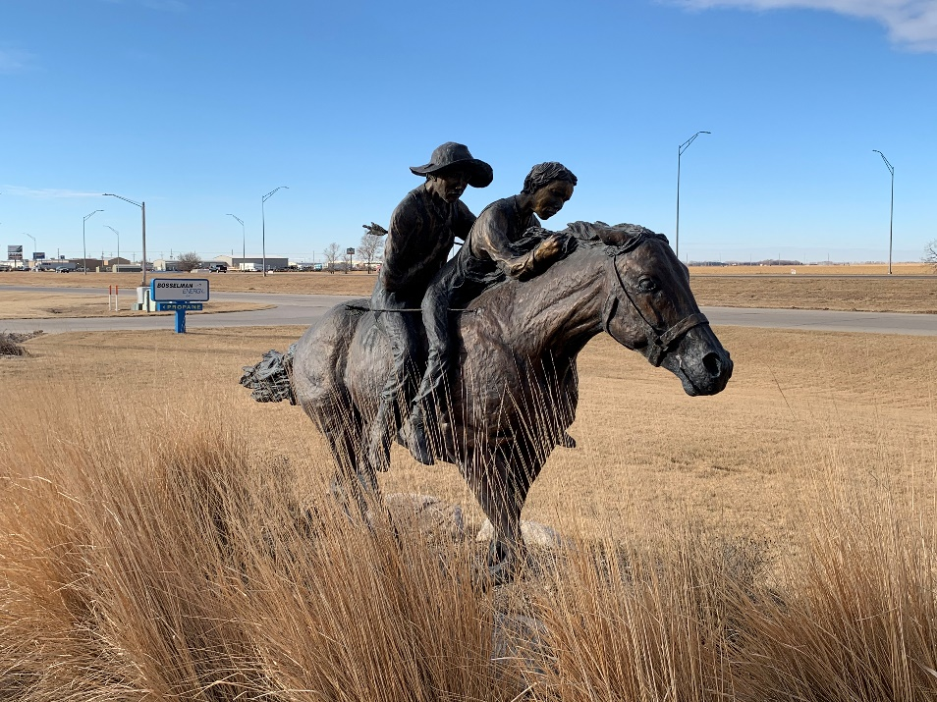
The Martin Brothers and Their Escape, Immortalized. Nebraska

After leaving Grand Island, we made our way south toward the border of Kansas for another site evaluation. Here, we met another potential partner, who also happens to be a farmer with access to good land. He was interested and impressed with our green ammonia project, and we left with even more enthusiasm about things to come.
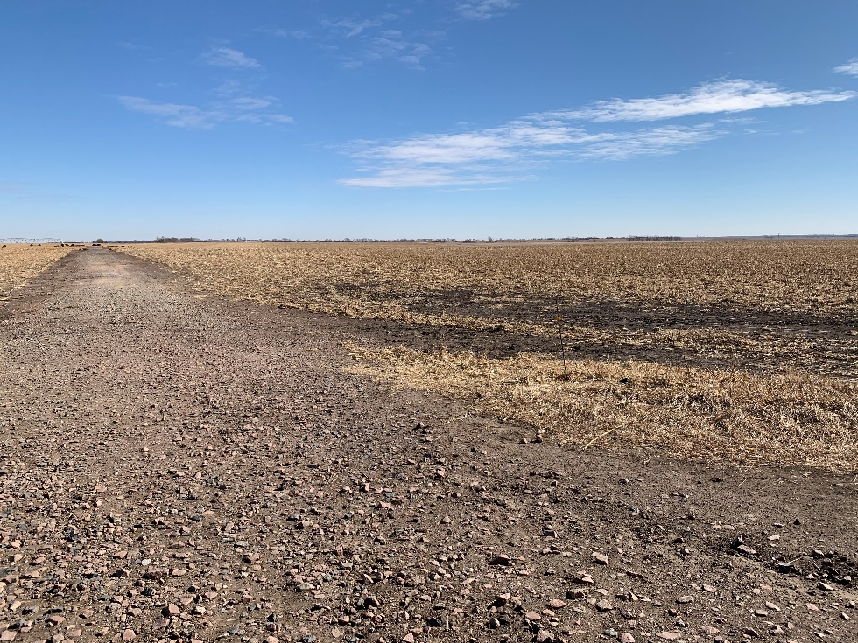
Another Potential Site, Near Nebraska and Kansas Border
On the way back toward Denver by way of Kansas, we passed by more interesting projects including the Nebraska Nitrogen plant, which produces anhydrous ammonia. As we pulled up to take a picture of the plant, I rolled down my window and unlocked my iPhone. A gentle hum was resonating from around the main reactor stack, possibly from the integrated compressor which pressurizes the hydrogen and nitrogen while these chemicals are routed into said stack. We will use a similar system for our Haber-Bosch plant, as the technology is time-tested, reliable, and durable. It hasn’t changed much in 100 years. However, their method for producing hydrogen is a bit different than how we will make it. We will use water instead of natural gas for our hydrogen; but it’s still important to get to see and get to know the industry – and really, what we will be up against.
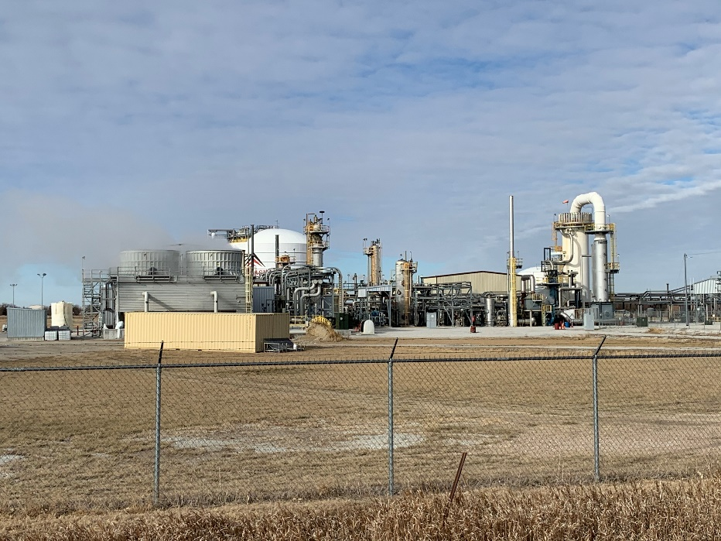
Nebraska Nitrogen
Our last major stop before Denver was the National Orphan Train Complex in Concordia, Kansas. The extent and history of the orphan train program are well documented here. Thousands of orphans in crowded eastern cities were relocated to the Midwest to live with families, often farmer families. The goal, naturally, was for the orphans to grow up in a stable environment and lead a better life than they may have had on the streets of the east coast. One of my great grandmothers was part of this program. She was an orphaned Italian immigrant who was relocated to Minnesota to live with a Polish family. It worked for her. She grew up to become a healthy and productive member of society.

The museum, and the short accompanying documentary inside, presented the program as a general success which helped many forgotten children to make something out of their unfortunate initial circumstances. The visit was moving and prompted me to think about my own circumstances growing up, and how lucky I’ve really had it. After we departed from the orphan museum, with a richer perspective on the Great Plains, we made our way back to Denver where we flew out of the following morning.

Our next trip will likely be around South Dakota and Northeast Nebraska for some more site and business visits. Currently, we are looking at possibly March or April, so stay tuned. More to come!

- Nathan Crary
Senior Project Engineer
Green Play Ammonia

